**TEJ4M Summative: Project Proposal**

**By**

**Saahiti Annamneedi and Alisa Nikiforova**

**For**

**Mr. Laxton**

**May 13, 2014**

**Project Proposal**

Purpose: To emulate a packaging factory that sorts products according to size and places them in corresponding sleeves

Tasks:

1. Measures dimensions of material:

The SONAR will measure the distance between its sensor and any matter in its way. Since the product and conveyor belt are located at different distances from the sensor, our code will use this difference to distinguish between the two and measure the product’s size. The products will be of similar width but different lengths.

1. Sense colour of packaging material:

Uses colour sensor to distinguish between packaging materials of three different custom size, where ach colour represents a size.

1. Packaging and unloading materials:

Products will be placed into packaging sleeves on a conveyor belt. We be simulating a delivery truck for pick-up.

1. Transport materials:

Uses Servo motor to transport material on a conveyor belt to a delivery truck

Desired programming language: Arduino

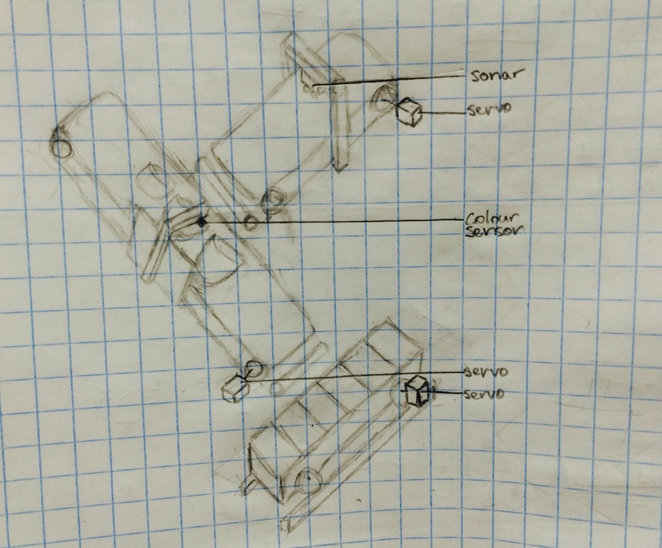

Figure Sketch of packaging station